INTERNATIONALLY CELEBRATED PUPPET THEATER FROM VERMONT
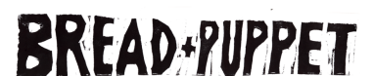
SUNDAY OCTOBER 9TH3PM JAMESTOWN CO “BIG PARK” ELYSIAN PARK
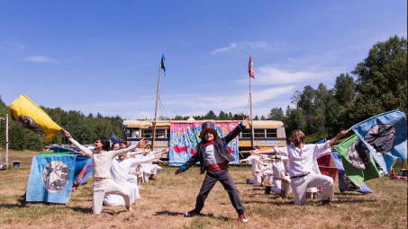
The circus is coming! The circus is coming! The Apocalypse Defiance Circus addresses the heart of the current moment with a bright barrage of acts spanning many moods, from slapstick to the sublime, all powered by a riotous brass band, stilt-dancers, blue horses, paper maché clouds and tigers. Building on the tradition of the Circus as popular spectacle, encompassing the ecstasy, sadness and absurdity of the world. After the show, Bread and Puppet will serve its famous sourdough rye bread with aioli, and Bread and Puppet’s “Cheap Art” – books, posters, postcards, pamphlets and banners from the Bread and Puppet Press – will be for sale.
COST $10-$25 Suggested Donation- No One turned away for lack of funds!
QUESTIONS? CONTACT: jamestownmercantilecafe@gmail.com

